TACO TRUCK ALL STARS CATERING
Whether large or small, formal or casual we offer a variety of catering packages to suit your needs for your next special occasion.
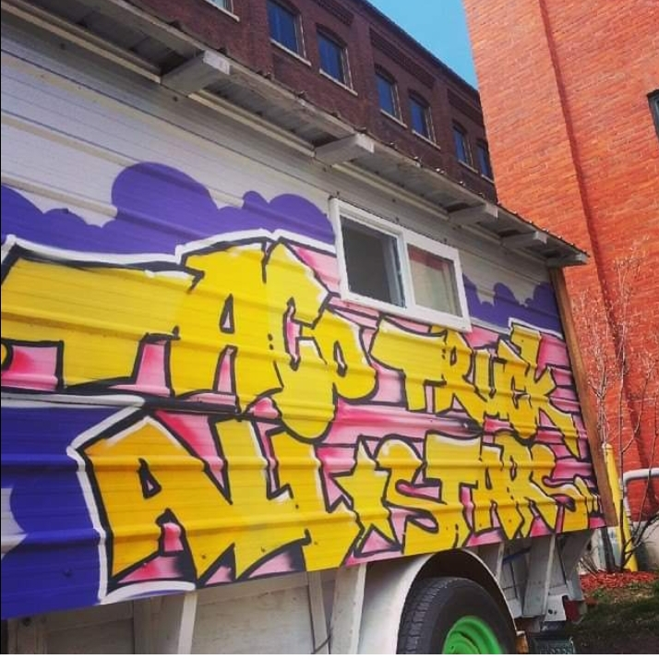
Taco Truck Lunch Service
Guests have choice of one entrée
One-time trip= $13/person
All you can eat= $20/person
Minimum amount= $250-up to 20 guests

Taco Truck Dinner Menu
We show up and feed your guests until they are full. 3 hours of service.
$20/person

Taco Truck Catering Light Menu
Choose 3 items from our list of Catering Menu items. We show up in the truck and feed your guests for 2 hours of service.
$15/person

Catering Menu Options
Tacos GF
3 tacos served on soft corn tortillas with your choice of filling topped with salsa, onion, cilantro

Taco Platter-GF
Comes with your choice of two tacos served with black beans and seasoned rice

Nachos- GF
Heaping mound of white corn chips covered in aged cheddar sauce, black beans, salsa, onions and cilantro

Rice Bowl- GF
Seasoned rice, black beans, shredded cheese, salsa, onion, cilantro served in a bowl atop soft corn tortillas

Taco Salad- GF
Heaping pile of lettuce cabbage, black beans, shredded cheese, salsa, onion, cilantro, radish, lime, served atop white corn tortilla chips

Burrito
Seasoned rice, black beans, shredded cheese, salsa, onion, lettuce, cabbage, cilantro served wrapped inside a flour tortilla

***GF=Gluten Free
JUST TACOS CATERING PACKAGES
Option A:
Guests pass through one time and are served 3 tacos per guest. Soft shell corn tortillas filled with guest’s choice of meat, salsa, onion, cilantro.
$12/person
Option B:
All you can eat tacos for your guests for 2 hours of service. Soft shell corn tortillas filled with guest’s choice of meat, salsa, onion, cilantro.
$15/person

Taco Party Extravaganza
All you can eat tacos with our Gourmet Toppings Bar. Let your guests create their own taco experience with over 20 toppings to choose from!
$18/person
*Recommended for large parties*
BUFFET STYLE PACKAGES
***Buffets are served by weight. We provide six (6) ounces of meat, eight (8) ounces of rice, eight (8) ounces of beans per customer. With tortillas and garnishes that is over two (2) lbs. per person!
***If you feel your crowd may be extra hungry, we suggest you place your order for more people.

Taco Truck Assisted Buffet
We come with the truck and set up a 16ft buffet. Buffet items include soft corn flour tortillas, seasoned rice, braised black beans, your choice of 2 meat options, shredded cheese, salsa, lettuce, onion, cilantro, cabbage, limes, jalapenos, sour cream, tortilla chips, and our selection of homemade hot sauces.
We stay for one hour of service, making sure everything is full and everyone is fed. All food stays with customer in disposable service ware. We provide all plates, napkins and silverware.
$18/person

Taco Truck Drop-off Buffet
We come with the truck and set up a 16ft buffet. Buffet items include soft corn flour tortillas, seasoned rice, braised black beans, your choice of 2 meat options, shredded cheese, salsa, lettuce, onion, cilantro, cabbage, limes, jalapenos, sour cream, tortilla chips, and our selection of homemade hot sauces.
We come with the truck, set up, and leave. All food stays with customer in disposable service ware. We provide all plates, napkins and silverware.
$16/person

